Ideal Meals After an Exercise
Protein helps repair worn-out muscles
Exercises speedy the breakdown of muscle protein. The rate at which this happens depends entirely on the nature of the training and the exercises—consuming high amounts of proteins after workouts is a good idea for the body to take in amino acids that it requires to repair worn out tissues. Also, amino acids in the body help to build new muscle tissue. Nutritionists have recommended 0.14-0.23 grams of protein per pound immediately after an exercise. Consequently, studies support the narrative that consuming 20-50grams of protein soon after the workout, helps the body to maximize performance.
Carbs help to build tissue.
The body glycogen is used during exercise, and carbs are used to replenish them. The amount of glycogen used depends on the intensity of the activity. For instance, endurance training force the body to use more glycogen than in regular training. Eating a high amount of carbs to restore glycogen is critical for the people who exercise regularly. Recent research suggests that consuming 0.5-0.5grams of carbs per pound within the first few minutes after exercise is a good move for glycogen resynthesize. Moreover, consuming a high amount of carbs together with protein after training optimizes glycogen synthesis and protein to rebuild the body.
Fat is an ideal food after exercise.
Fat might be a controversial meal under this category, but research shows that milk is effective in enhancing muscle growth after the workout. While the fight is known to reduce the absorption rate, it does not affect glycogen synthesis in the body. It is a good idea to limit fat intake, but taking a few fat products after an exercise does not affect the recovery process. Avocado, nut butter, and nuts are an excellent example of fats to take after workout. The foods listed above creates a great combination of meals suppliers the body with all the required nutrients after exercise. Consuming them within 30 minutes after an exercise would be a great deal to optimize the results. The primary aim of these meals after the training is to supply the body with the right nutrients for quick recoveries from worn-out tissues.
Featured image
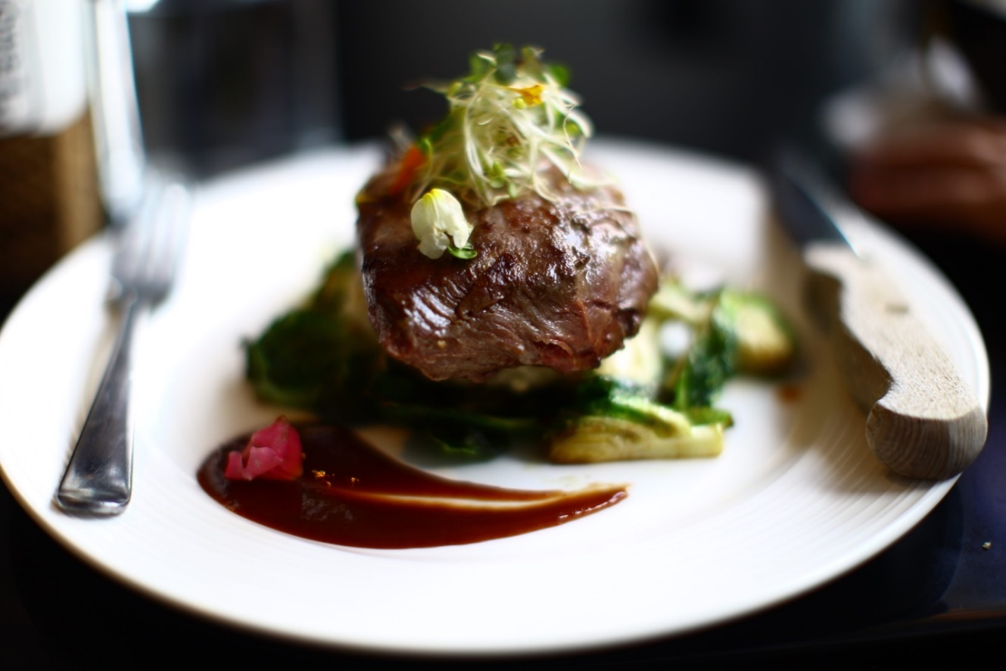

Other images
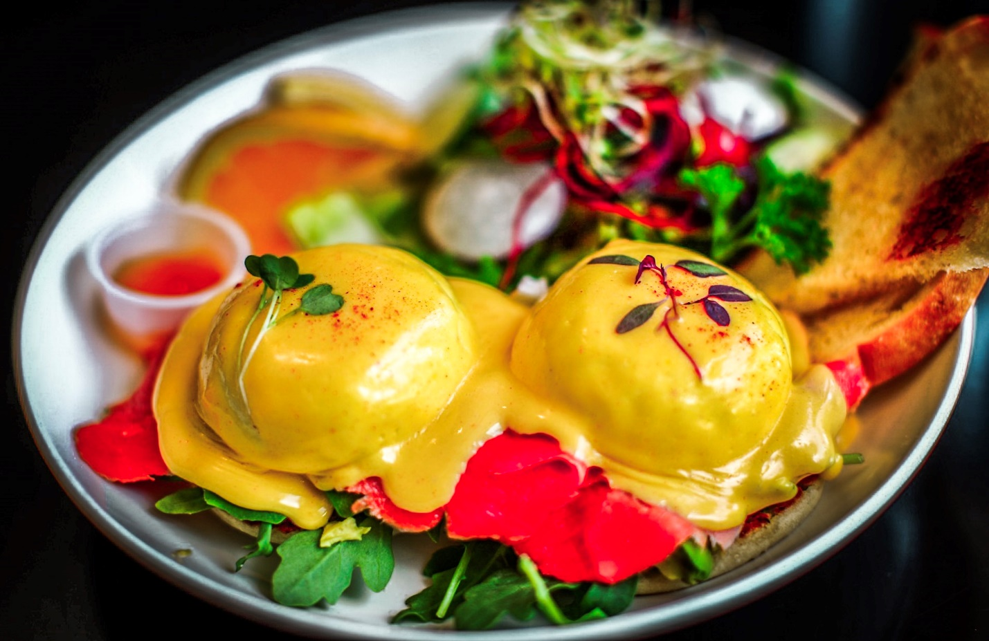
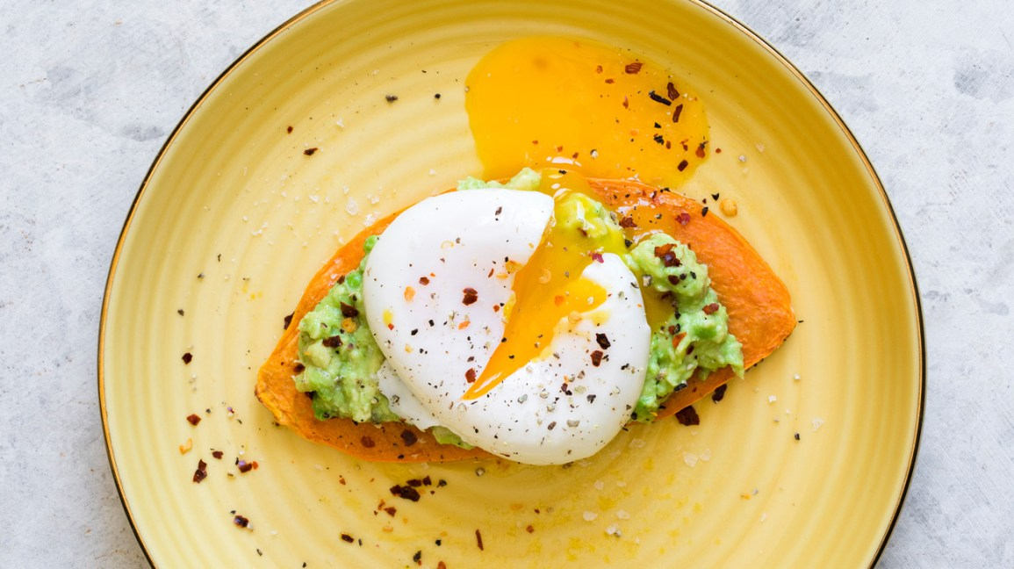

Links
https://www.healthline.com/nutrition/eat-after-workout#section4
https://www.medicalnewstoday.com/articles/322692

